1. Architecture
Configuration-filtered BOMs are derived from the 150% MBOM held in 3DEXPERIENCE and pushed
into Dynamics 365 Business Central (BC). There are three flows:
1. Send to ERP (BOM Widget) with a BOM open (and optionally a Product Configuration applied) the user presses the button; BC receives the top item and the multi-level BOM below it.
2. BOM sync loop (every 30 min) for every configuration already sent to ERP the filtered BOM is re-read from 3DX, and the differences (add / update / delete) are applied in BC.
3. Release Poller creates/updates BC item cards for manufacturing items that become RELEASED (or are edited after release). Dormant until Zenvo starts releasing items.
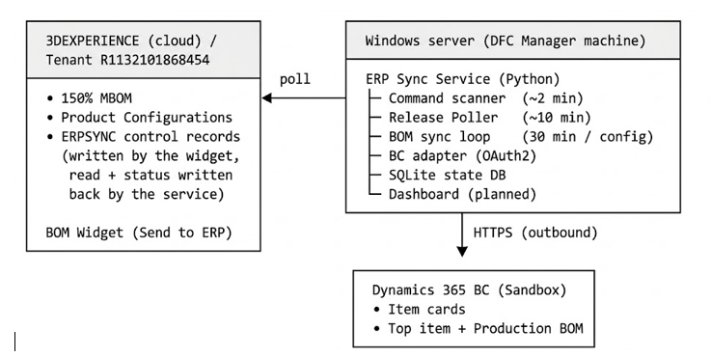
2. Data flows
2.1 Send to ERP (initial push)
1. The user opens a BOM root, optionally applies a configuration and presses Send to ERP.
2. The widget writes the ERPSYNC control record.
3. Within ~2 minutes the service picks it up and pulls a strictly filtered configured expand from 3DX (or an unfiltered expand when no configuration is applied).
4. It creates the top item in BC (No. = configuration name, or the root assembly's own part number when there is no configuration).
5. It guarantees an item card for every part in the BOM (see 5.3) and then builds the multi-level BOM: every assembly is a card with its own Production BOM, and each line carries the quantity of its own level.
6. It writes the status back into the control record and into SQLite.
2.2 The 30 minute loop
For each registered configuration: filtered expand → desired-state tree → comparison against BC (nothing is written when there is no change) → otherwise, per BOM:
- new part → guarantee card + add line
- quantity / unit change → rewrite the BOM lines
- part no longer in the 3DX BOM → **its line is deleted**
- manual BC changes → overwritten by the 3DX state (3DX is the master)
2.3 Release Poller
DFC Manager pattern: Federated Search for `state = RELEASED` and `modified > last cursor`, then a BC card fetch for each changed manufacturing item. Both the first release and any post-release edit are caught by the same query.
2.4 Revision change example
`SB00123-B` is released and used in BOMs. Revision C is released:
1. The Release Poller creates the `SB00123-C` card.
2. As soon as the configured BOM resolves to C, the 30-minute sync removes the `-B` line and
adds the `-C` line. The old `-B` card stays in BC (it is never deleted).
3. Field mapping
Item No = Enterprise Item Number + `-` + revision letter (`Partrevision` on items)
Description=| Title
Base Unit of Measure `PCS` for discrete parts; the real unit for continuous materials
Replenishment System Make → Prod. Order; Kit / Buy / anything else → Purchase; top item → Prod. Order |
Make Buy= Make Buy value (informational only)
Quantity= quantity at that level; real magnitude for continuous materials.

4. Synchronization Rules
4.1. Item Numbering Rules
# | Rule Name | Description & Implementation
1.1 | ERP Item Number Format | ” Enterprise Item Number” +”- “+” Revision Letter” (e.g., 1006412-A, SB00123-B). All characters are stored in uppercase.
1.2 | Missing Enterprise Number | Items without an Enterprise Item Number and their dependent BOM lines are skipped and logged as EXCLUDED. (Exception: The root item defaults to the 3DX name and is logged).
1.3 | Field Length Constraint | Business Central Item No. is limited to 20 characters. Identifiers exceeding this limit are truncated to 20 characters and logged as an error.

4.2. Top-Level Item Rules
# | Context | Specification
2.1 | Configured Push | Top Item No. = Product Configuration Name (e.g., ZA-00000017).  Top Item Description = Product Configuration Title.  The top item replaces the root, and its BOM contains configuration-filtered children.
2.2 | Unconfigured Push | The BOM is transferred unfiltered. The top item No. defaults to the root Manufacturing Assembly part number (Rules 1.1) upon user confirmation.
2.3 | Replenishment System | The top-level item card is created with Replenishment System set to Prod. Order.

4.3. Bill of Materials (BOM) Management
# | Rule | Policy
3.2 | Filtering | Strict filtering applies; components outside the active configuration scope are excluded.
3.3 | Structure | Multi-level; every assembly with child components generates a Production BOM in Business Central linked via Production BOM No.
3.4 | Quantities | Reflects discrete level occurrence counts (no rolled up/cumulative math).
3.5 | Sync & Updates | State comparison is performed prior to writing. On changes, the BOM status shifts to Under Development, lines are completely rewritten, and status is restored to Certified.
3.6 | Master Data Authority | 3DEXPERIENCE is the single source of truth. Parts removed from 3DX are deleted in BC; manual edits in BC are overwritten on the next sync cycle.
3.7 | Conflict Resolution | If two configurations require conflicting structures for the same assembly, existing data is preserved (first write wins) and a CONFLICT warning is reported.
3.8 | Card Generation | BOM components missing an Item Card in BC are provisioned automatically with default parameters (PCS, RETAIL, RESALE).
3.9 | Phantom Items | A Phantom designation on MBOM triggers a warning log only; item cards and BOMs are still processed. EBOM phantoms are treated as standard structures.

5. System Execution & Operational Schedule
- Access Control: The manual trigger (Send to ERP) is restricted to the Leader context.
- Request Handling: Execution generates an ERPSYNC_<id> control record. Repeated clicks query status rather than duplicating requests.
- Security & Environment: Service account credentials reside strictly in service/config.json on the server and are excluded from repositories. Required BC permission sets include D365 BUS FULL ACCESS, D365 BUS PREMIUM, MFL BASIC/CONNECTOR/PAYMENTS, and ZEN ERP SYNC.

